1. Introduction
This report provides an interim review on the progress of the MSc dissertation project titled "Sustainable Crop Yield Prediction via Multi-modal AI." Accurate crop yield forecasting is a critical component of agricultural sustainability and food security. While modern AI systems leverage satellite imagery and meteorological data, they often remain fragile under real-world conditions like cloud occlusion or missing sensor readings. The primary aim of this project is to develop and rigorously evaluate a Gated Multimodal Deep Learning architecture—specifically a Gated Multimodal Unit (GMU)—that dynamically adapts to missing or corrupted input modalities.
Changes to Scope, Aims, and Objectives Since the original project proposal, the core aims remain intact, but the scope of the evaluation and architectural baselines has been significantly enhanced to ensure greater real-world applicability.
- Baseline Evolution: The unimodal weather baseline has been specifically formalized as a highly capable Bi-LSTM network processing High-Resolution Rapid Refresh (HRRR) meteorological data, while the visual branch utilizes a robust CNN encoder for Sentinel-2 spatial tensors as seen in fig 2.
- Focus on Geographic Fairness: The project's scope has successfully expanded to proactively ensure geographic fairness in model predictions. The evaluation framework now explicitly benchmarks against geographic disparity to ensure the model performs reliably across diverse agricultural zones, rather than just optimizing for an ideal-case overall error rate.
- Infrastructure Prioritization: To guarantee a solid foundation for the complex multimodal fusions, immediate objectives prioritized the establishment of a deployment-ready, highly robust data infrastructure.
2. Summary of Progress Against the Original Plan
Progress has aligned exceptionally well with the initial analytical process outlined in the methodology, advancing smoothly from data alignment to smart fusion prototyping.
Information Gathered and Data Alignment: The CropNet Benchmark dataset was successfully gathered and profiled. A major milestone was achieved by explicitly aligning USDA historical soybean yield records (2016–2022) with complex environmental HRRR data and Sentinel-2 satellite imagery. This provided a rich, multifaceted dataset covering 3,535 county-year records across 15 states.
Addressing the Tasks:
- Modality-Specific EDA: A programmatic intersection between the Sentinel FIPS codes and USDA labels was successfully conducted, establishing a precise understanding of the available high-quality multimodal overlaps (yielding 105 matching records).
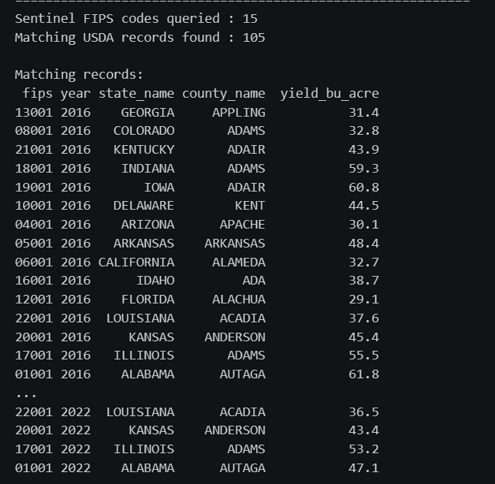
Fig 1:- Unifying the datasets of sentinel with usda for getting grounded truth labels for training
- Optimized Training Strategy: A strategic, phased modeling approach was established. Phase 1 (Weather-only Bi-LSTM) leveraged a robust universe of 2,828 training USDA records using a rigorous stratified random split, ensuring a highly stable baseline before advancing to Phase 2 (Satellite) and Phase 3 (GMU fine-tuning).
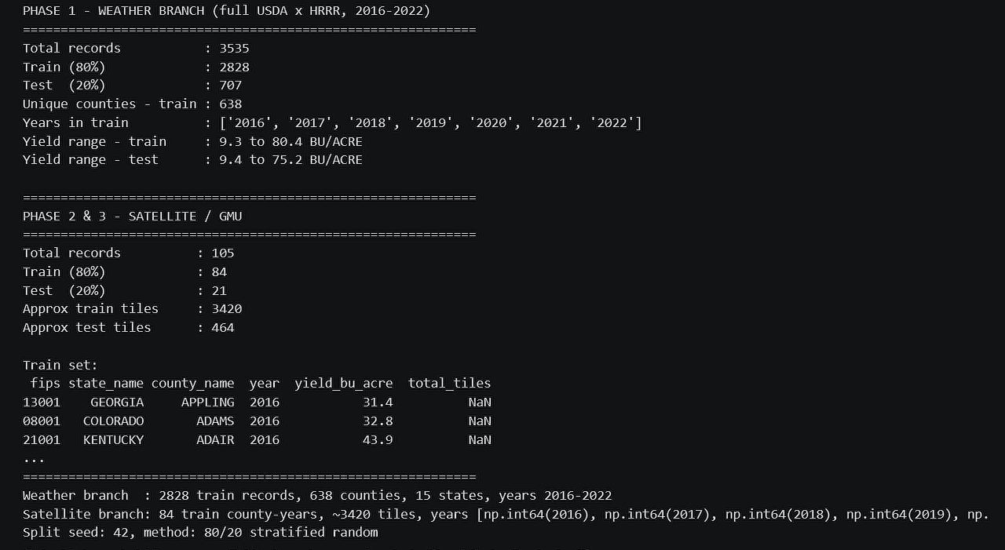
Fig 2:- Training info of both the weather and sentinel visual branches
- Feature Engineering Innovations: The target variable (yield in BU/ACRE) was effectively log-transformed to benefit optimization after initial distributions rejected normality tests. Furthermore, a sophisticated mathematical mitigation—the Jensen correction—was successfully derived and applied to ensure back-transformed predictions maintained high fidelity.
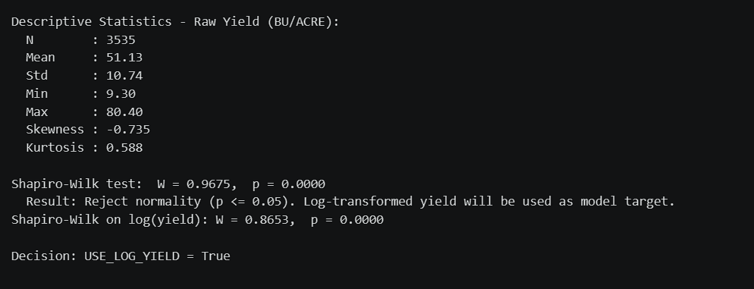
Fig 3:- Descriptive statistics of the tabular data of WRF-HRR data
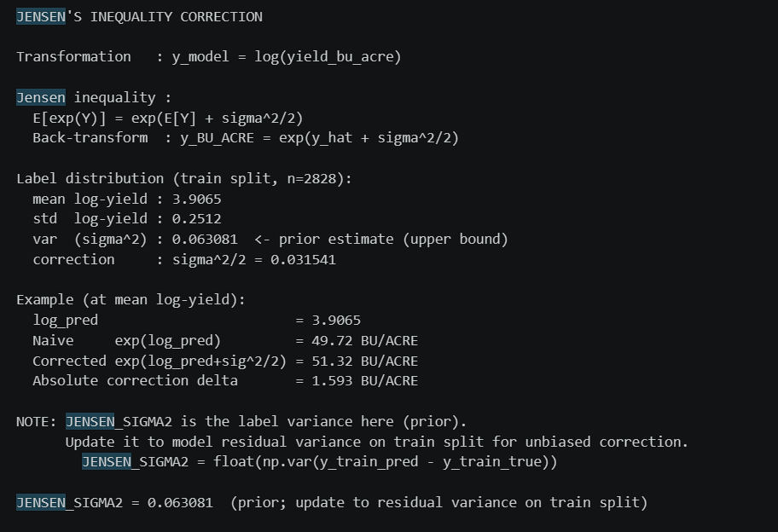
Fig 4:- Jensen correction being applied
3. Summary of Achievements
Considerable milestones have been reached, successfully transitioning the project from a theoretical framework to highly functional working software prototypes.
Milestones and Deliverables:
- Unimodal Baseline Deployment: The Phase 1 Bi-LSTM weather regressor has been successfully defined, pre-trained, and evaluated, providing a strong, deployable predictive system.
- Explainability (XAI) Integration: SHAP (SHapley Additive exPlanations) was successfully integrated to provide the deep interpretability often missing in agricultural AI. This advanced feature-level analysis revealed critical insights, such as dew point temperature and surface pressure functioning as top-ranked predictive features.
- Modular Software Architecture: A robust, reproducible PyTorch implementation has been developed. The elegant codebase handles global seed reproducibility, dynamic data ingestion, and highly automated performance metric tracking.
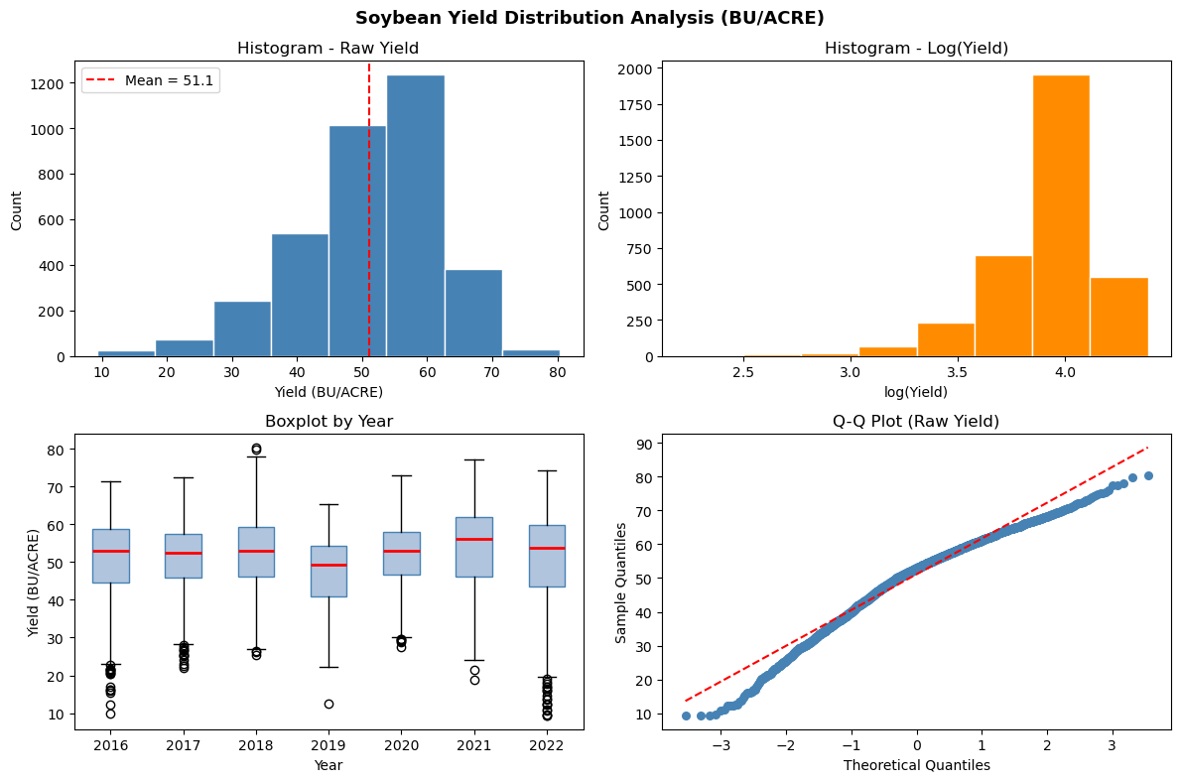
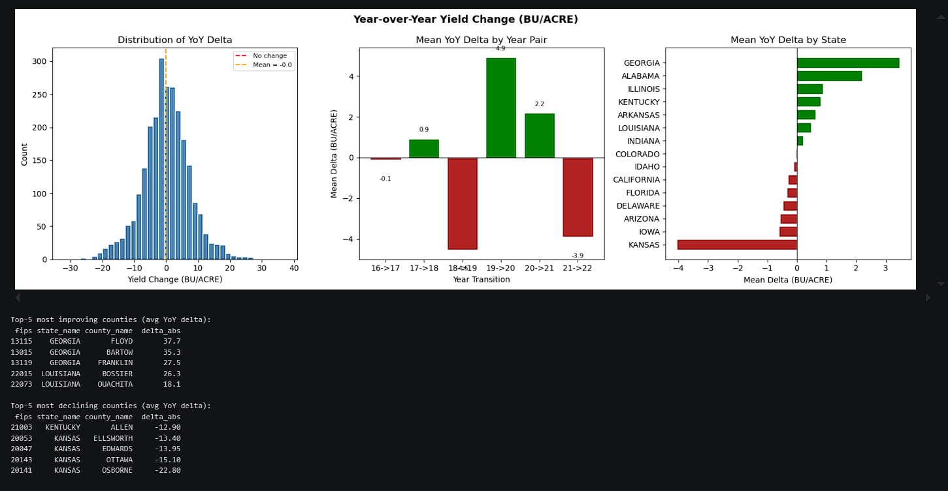
Fig 5:- Box and histogram plots of usda yields
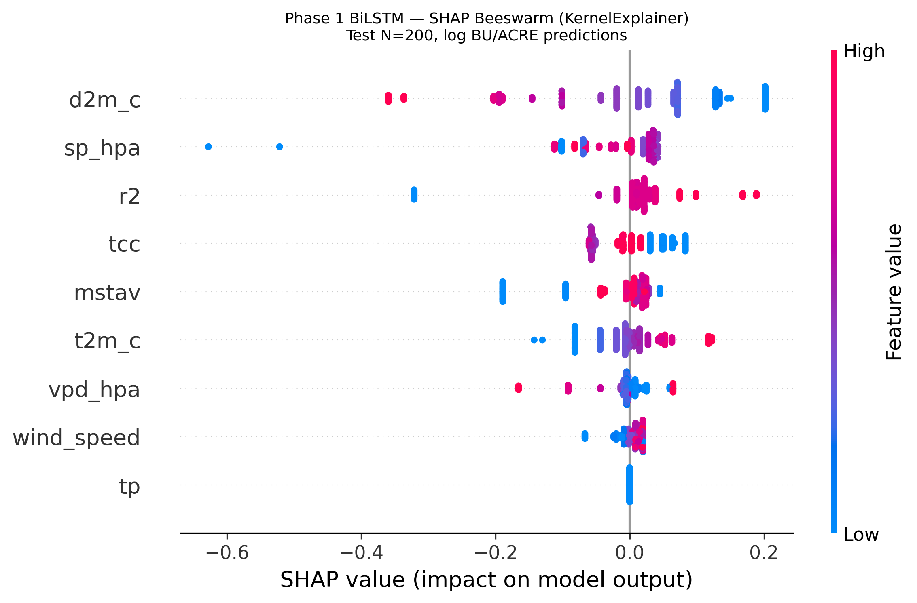

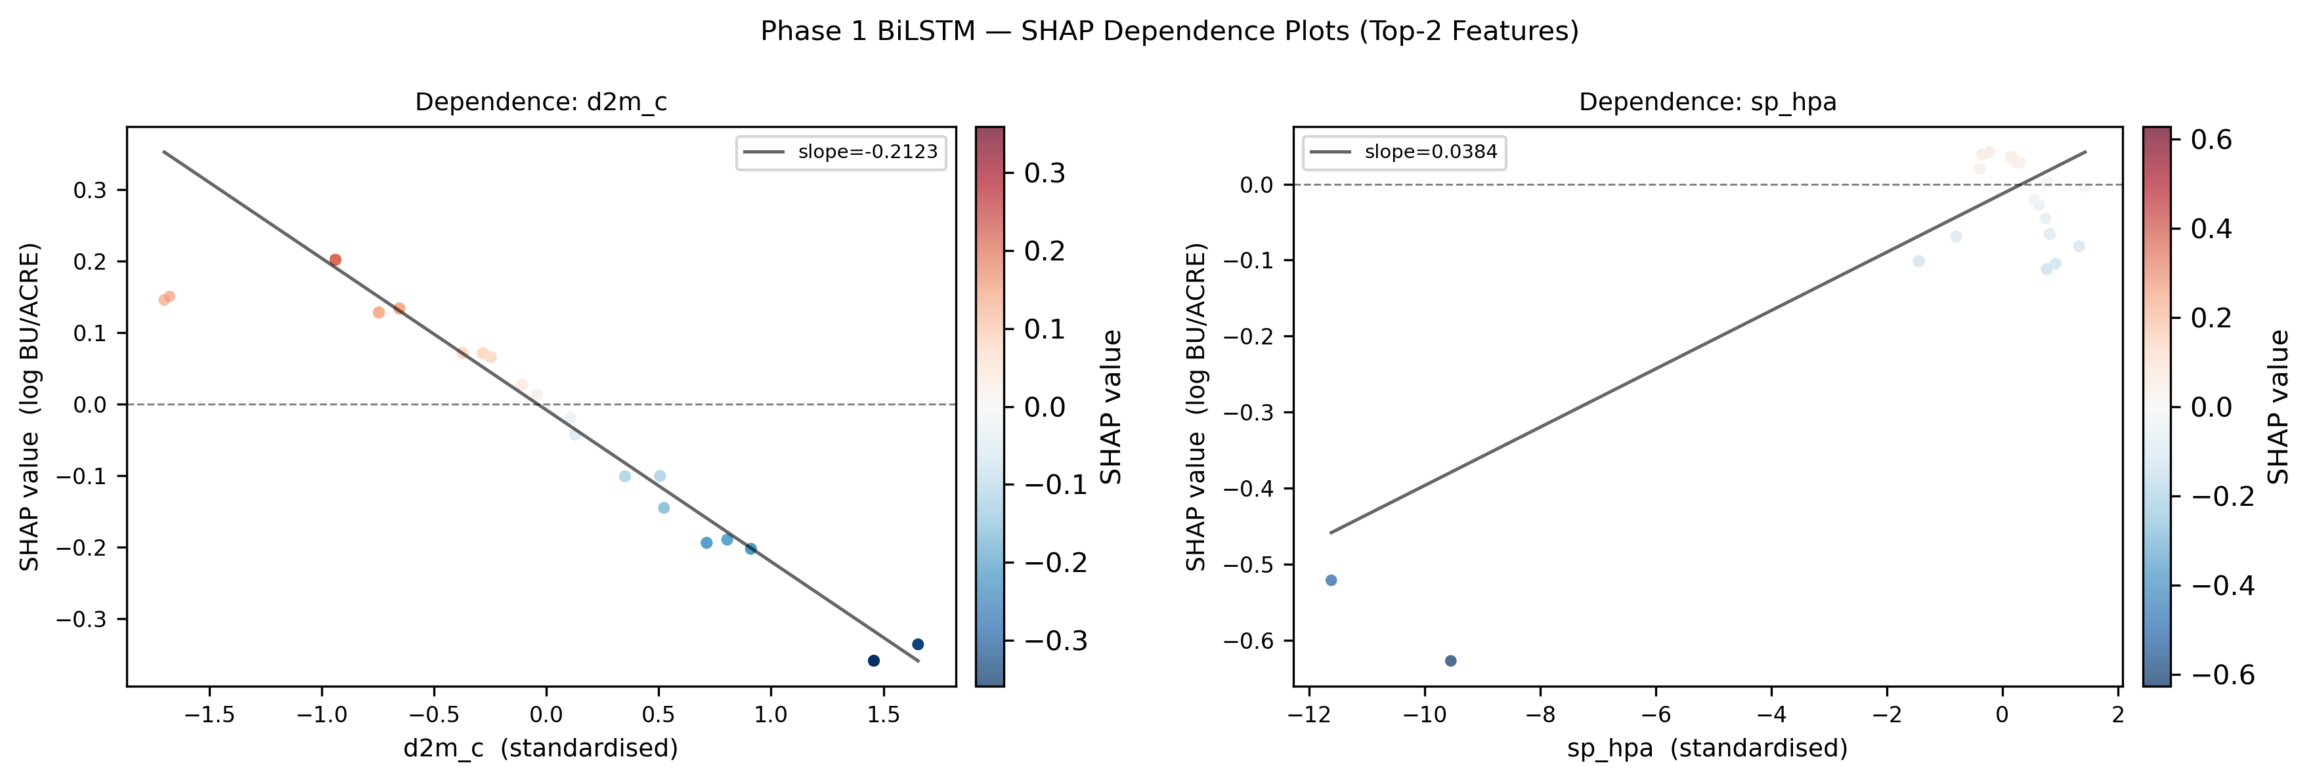
Fig 6:- SHAP explanation of features

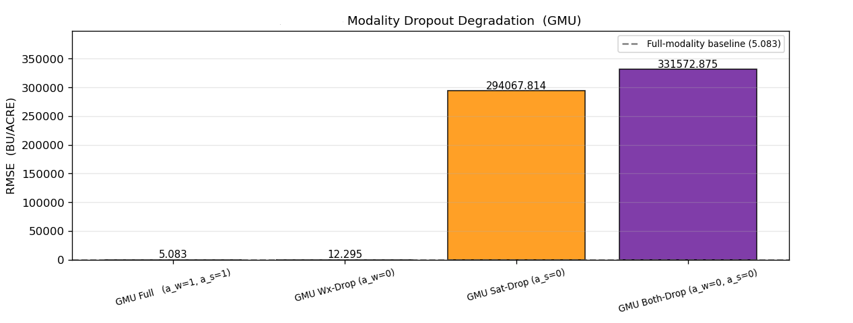
Fig 7:- GMU Modality drop out

4. Revised Plan for the Remaining Period
With highly capable baseline models and a robust data alignment infrastructure successfully established, the remaining period will pivot directly to the culminating phase of the research.
Revised Task List:
- Final Evaluation & Thesis Writing (Weeks 21-23): Finalize the Dual-Stream GMU architecture, complete comprehensive stress-testing against the baseline models, quantify generalization and geographic fairness, and compile all findings into the final PhD dissertation and presentation.
5. Evaluation Strategy and Execution
The project's evaluation strategy is highly rigorous and tailored to measure both pure predictive accuracy and real-world system resilience.
- Core Performance Metrics: The system's standard accuracy is measured using Root Mean Square Error (RMSE), Mean Absolute Error (MAE), R-squared ($R^2$), and Mean Absolute Percentage Error (MAPE).
- Resilience and Robustness Metrics: To quantify the model's ability to handle missing or noisy inputs, the evaluation employs specialized metrics including the Relative Degradation Index (RDI) and Robustness Retention Score (RRS).
- Simulated Degradation Testing: The architecture's stability is stress-tested through explicitly designed scenario injections, including:
  - Image Dropout: Random cloud masking applied to spatial tensors.
  - Weather Dropout: Random environmental feature masking.
  - Structured Dropout: Seasonal data removal simulating prolonged sensor downtime.
  - Combined Dropout: Multi-modality corruption.
- Statistical and Geographic Validation: The models undergo paired t-tests and 5-fold cross-validation to ensure statistical significance. Geographic holdout validation and state-level CV-error weighting proactively track and ensure fairness across diverse agricultural zones.
- Temporal Non-Stationarity Validation: A strict Leave-One-Year-Out (LOYO) cross-validation strategy is implemented specifically for extreme weather years (e.g., 2022) to verify the architecture's capacity to maintain strong predictive performance despite temporal data shifts and climate variability.

